Assignment 10.2

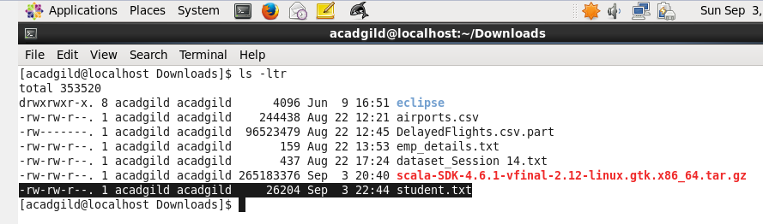

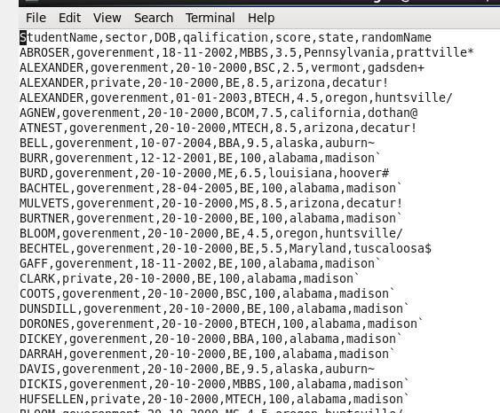

Copying the data set in to HDFS which will be further loaded into HBase.

Including few jar files of HBase to the Pig classpath

Now start HBase shell and create a table.

